Sponsor a school

Name of the School : ZPHS JALALPUR
Address : ZPHS JALALPUR, Mandal:
Bommalaramaram, District: Yadadri,
It's about 20 Km from ECIL X Roads

Principal Name :Pendem. Nagarjuna.
Contact Phone number :9912070810

Classes :VI to X Telugu and English medium Total 10 classess
Strength : 165

About School w/ photos :

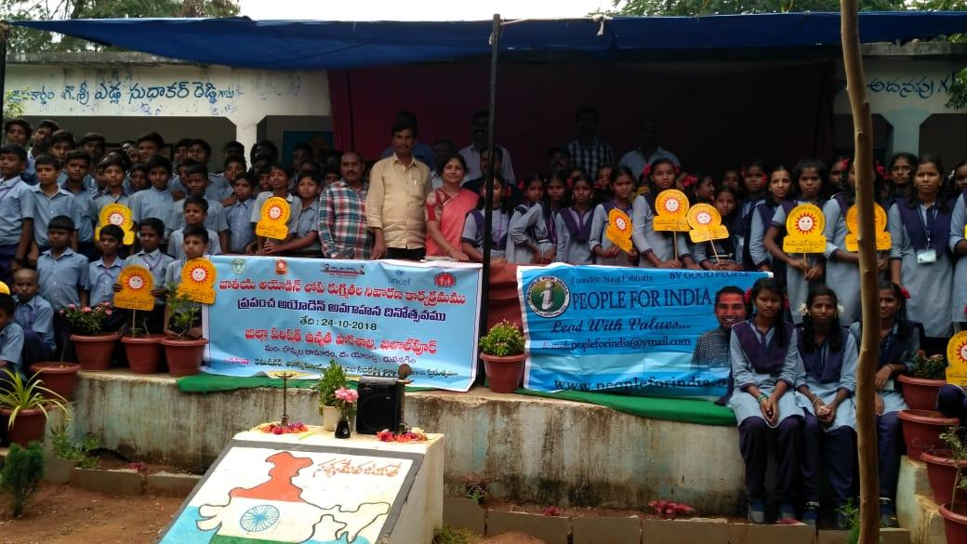 | 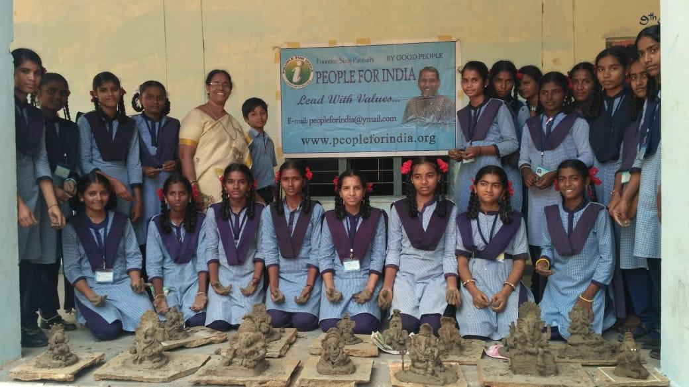
Global Iodine Deficiency Prevention Day | eco friendly ganesha

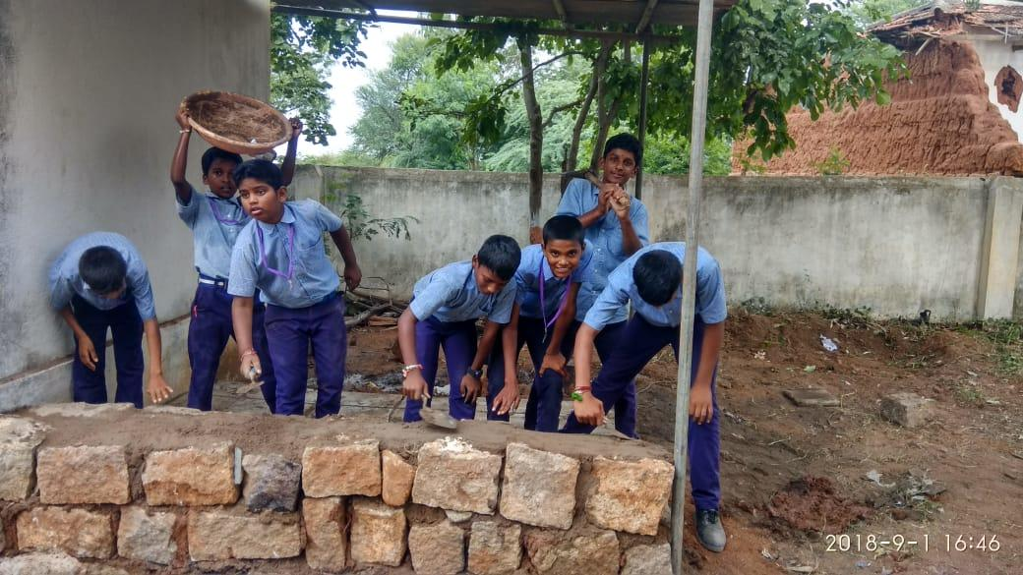 | 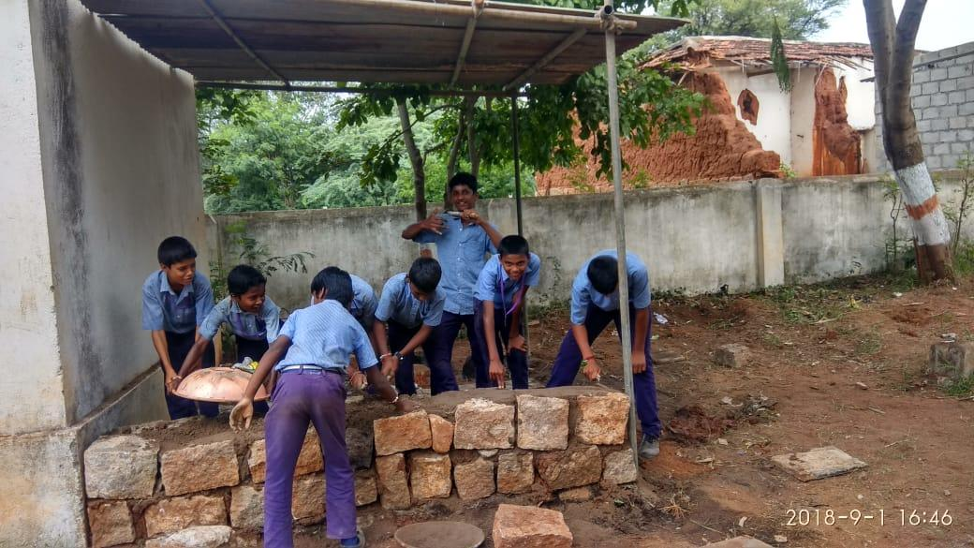
School students building their own kitchen | They are building for cooking the food during afternoon.

About Principal w/ photos :
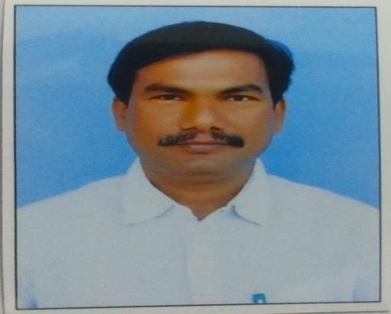
Sir I am Pendem Nagarjuna working as Gazetted Head Master at ZPHS JALALPUR, I have completed 32 years of service, my hobby is conducting social awareness programs among people as well as pupil on various society issues. I have rendered my service in Post Literacy program in district level previously. I am conducting classess on lead with values manual which is prepared by Respected Suraj Pabbathi sir, Since last six years I have participated in Elocution competition at district level with my students and got state level prizes also. I am happy to share that now I am going to conduct the PFI activities at Bommalaramaram and Thurkapallymandals.I have already submitted my programs pics recently orgonized in my school. I am happy to inform you that I am going to conduct Seminar on PFI activities with all High School Head Masters on 24-11-2018.we expect your continued support to pupil.... Thank you sir.

Sponsor Name :Sharvani Tota
About Sponsor w/ photos : :

Needs:

Item No # Description Priority Amount
1 Painting the school building Very High 30000

Details:

Our school is most senior in this area ,60 years completed, we are going to plan for colouring the total classrooms. this school has three blocks consisting four classrooms in each block, it may costs Rs.50 000 for each block, kindly sanction a project to colouring at least one block separately by PFI

Photos if needed

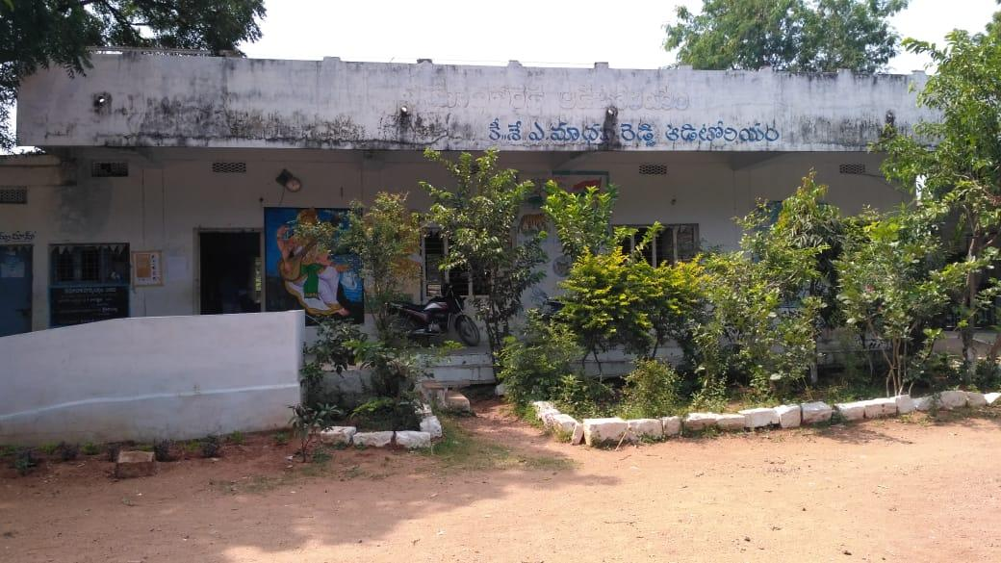 | 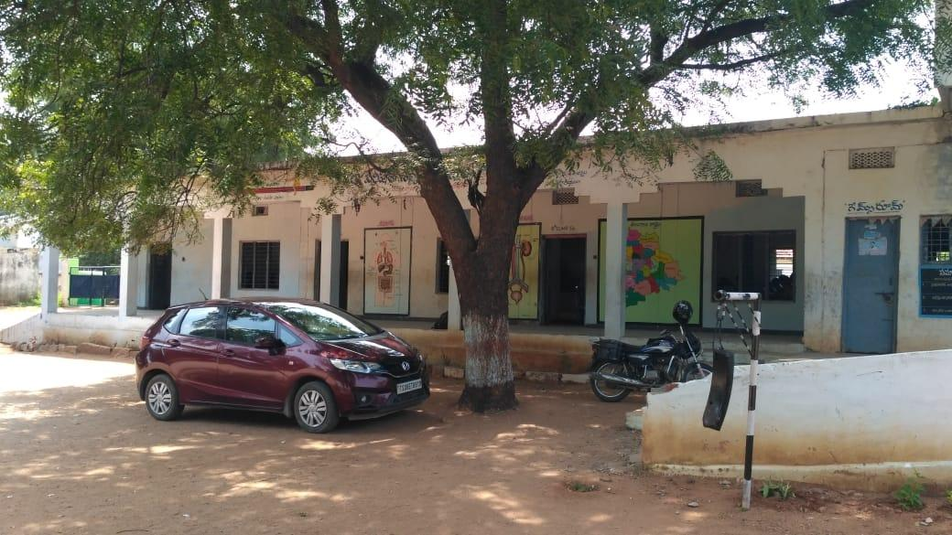
This is another block for colouring sir | This is another block for colouring sir

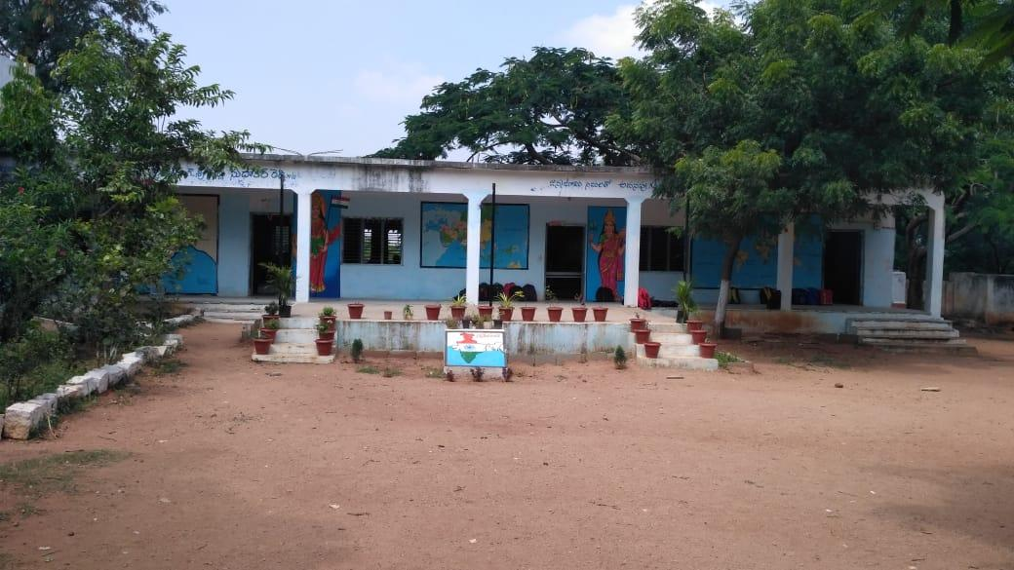
Interior and Exterior painting for the classrooms block

Item No # Description Priority Amount
2

Details:
Photos if needed

Item No # Description Priority Amount
3

Details:
Photos if needed

